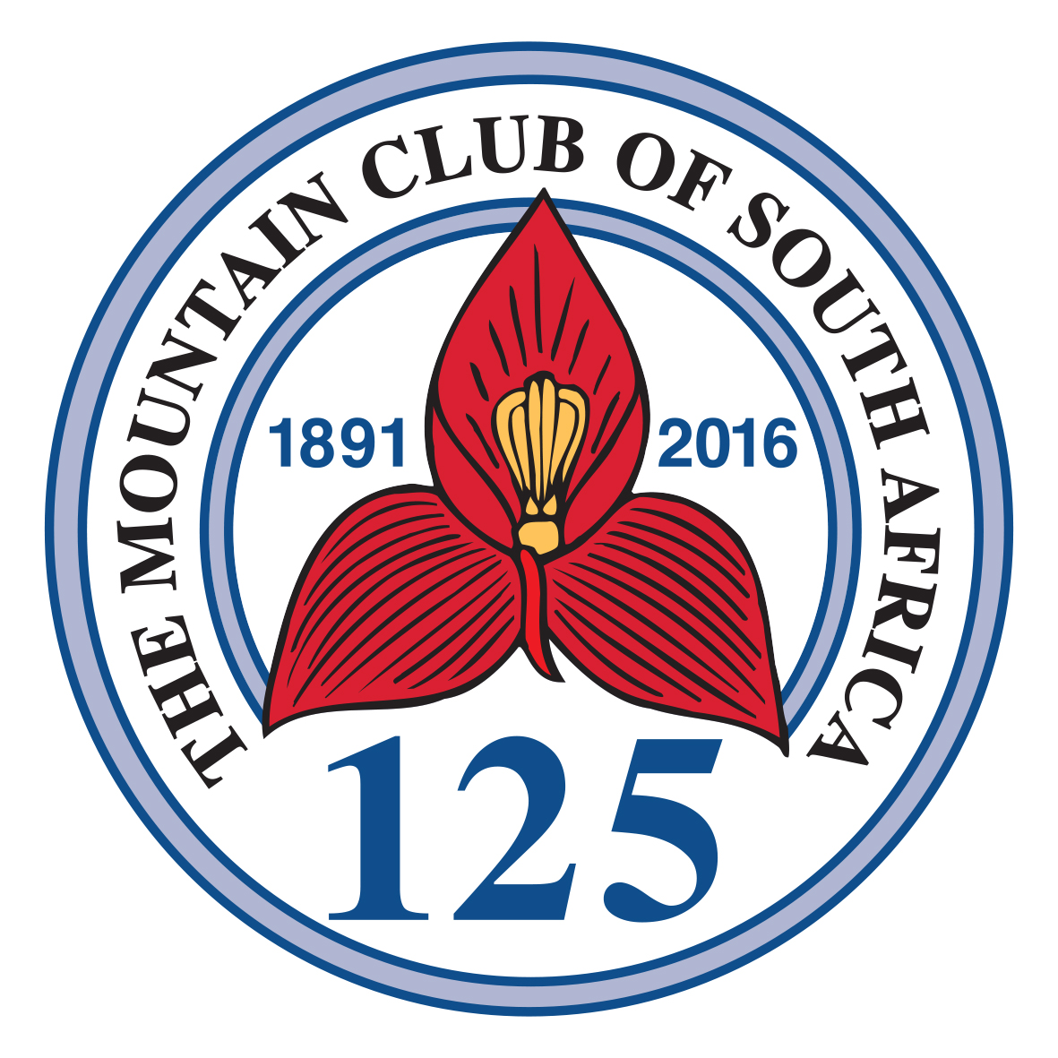 | The Mountain Club of South Africa  Founded 1891  Johannesburg Section  Established 1931  EXPLORE ● DISCOVER ● CONNECT ● PROTECT __________________________________________________________________________  173 Republic Road (entrance 46 4th Ave South) Fontainebleau • Johannesburg  P O Box 1641, Houghton, 2041 • Republic of South Africa  Telephone: (027) (011) 067 0326  Office hours: 15h00 to 18h00 Mondays, Tuesdays, Thursdays and Fridays  15h00 to 19h00 Wednesdays  Email: admin@jhb.mcsa.org.za • Website: www.jhb.mcsa.org.za

Application for Grant/Approval

- Name of expedition

- Name, email address, telephone number and address of leader

- Country and area to be visited

- Objectives of expedition

- Duration from to

- Team members
 | Name | MCSA membership No | Age | Nationality | Occupation | Relevant experience
1
2
3
4
5
6
7
8
9
10
11
12
13
14
15
16
17
18

- Give names, email addresses and telephone numbers of two referees to which the MCSA may apply concerning the general standing of the expedition and its members.

- Budget
 | Amount | Comment (optional)
8.1 Total costs
8.1.1 Travel
8.1.2 Accommodation
8.1.3 Food and stores
8.1.4 Equipment (*)
8.1.5 Fees and permits
8.1.6 Medical kit
8.1.7 Hire of labour
8.1.8 Hire of equipment
8.1.9 Insurance
8.1.10 Miscellaneous

(*) To 8.1.4 Please provide full list of equipment included in this figure
Description | Amount each | Amount total

  - Income
    - Total personal contributions of all team members
    - Value of other sponsorships granted
    - Value of other sponsorships applied for
    - What other organisations and sponsors have you approached for sponsorship and what are the results thus far?

  - Loans
    - Do you require any special equipment that the section might be able to loan to you?

    - Do you require any special equipment that members of the MCSA might be able to loan to you?

  - What do you think would be an appropriate sponsorship by the JHB section?
    - Cash amount detailed (optional)

    - Otherwise (loan, support)

- Permits
  - To whom have you applied?
  - When do you expect a decision?

- Planning
10.1 Do you have all necessary information about travel, visa and accommodation?

10.2 Do you have all necessary information about health requirements?

10.3 Are you familiar with the customs requirement of the country you are visiting and its regulations regarding deposit of money against import of equipment (if applicable)?

10.4 Do you have or have applied for the latest expedition regulations of the country you are visiting?

10.5 Can you call on financial reserves in the event of an emergency? (Insurance or otherwise)

10.6 Whom have you consulted about the expedition

11. Feedback
11.1 Do you agree to submit the completed “Expedition Feedback” form within six weeks of your return to South Africa?

11.2 Will you give a slide show to the Johannesburg section free of charge?

11.3 Will you write an article for the MSCA journal?

11.4 Would there be any other benefit to the Johannesburg section resulting from your expedition?

.

- Give any other additional information that you think may help the MCSA to reach a decision.

- Name of account holder, Bank, Branch and account number to which grant should be send.

Name Bank Branch code A/C number

Signed:

Expedition Leader

Date Place

