NATIONAL NEWSLETTER – JULY 2018
- ANNUAL JOINT MEET
- UIAA
- ASIAN ALPINE E-NEWS
- FACEBOOK AND WEB PAGES
- SECTION NEWS
- SNIPPETS
- ANY NEWSWORTHY ITEMS

- HOTTENTOTS HOLLAND SECTION - ANNUAL JOINT MEET
The Hottentots Holland section would like to invite you to the annual Joint Meet held at the Johnson Hut in the lovely Hottentots Holland mountains.
Arrival 22 September, 3pm at Vergelegen Estate, Somerset West. Relax at the hut or dip in the pool while planning the next day’s activities. Bring n braai merriment while enjoying the sunset over Table Mountain and False Bay. Sleeping mattresses available in the hut (20 of) or sleep under the stars or tent.
On Sunday we offer:
1. a gentle hike up the Landroskop gorge, with a variation into the Koffie Kloof. (2 A+).
2. a more strenuous but interesting scramble up the Landroskop Needle (3C).
3. a possibility to trad climb the Lang Klippie (4D).
4. hike up to Chipaway Cave and spend the night (3C).
2. UIAA
Some selected highlights of recent UIAA activities are provided below. Members are encouraged to go to http://www.theuiaa.org/ to find out more about the UIAA‘s important activities.
2.1 MOUNTAIN SAFETY: INNOVATION AND RESEARCH SPEARHEADED BY UIAA SAFECOM
Uniting representatives from global climbing equipment manufacturers, testing laboratories and national delegates from UIAA member associations, the annual UIAA SafeCom meet is a crucial opportunity for leading players in the field of mountain safety to discuss the current challenges facing the climbing world and to present progress on innovations and developments. This year’s session was held in Porto, Portugal from 14-16 May and hosted by Clube Nacional de Montanhismo CNM.
The UIAA currently counts 77 active safety label holders from 20 countries. This represents a rise of 11 manufacturers since 2017. While half are European-based there is a steady rise in requests from Asia and the Americas.
In terms of the UIAA Safety Label, the most popular standard certified is for connectors followed by dynamic ropes, harnesses and slings. Over the past eighteen months, the UIAA has certified its first labels for crash pads. A full list of certified UIAA equipment can be found on the dedicated database.

2.2 MOUNTAIN PROTECTION COMMISSION
The Lake District, one of the United Kingdom’s most impressive and distinctive outdoor environments, provided a fitting backdrop for the recent annual meeting of the UIAA Mountain Protection Commission (MPC).
Responsible for the developments of some of the UIAA’s most important international projects, the Commission reflected on the achievements and progress made over the past twelve months and some of the challenges and opportunities which lie ahead.
The MPC has also confirmed then 2018 UIAA Respect the Mountains calendar. To see if there is an event near you please visit this web page: https://www.theuiaa.org/home/2018-uiaa-respect-the-mountains-dates-released/
2.3 MOUNTAIN SKILLS
The latest extract from the UIAA Alpine Summer Skills Handbook (https://www.theuiaa.org/uiaa/mountain-skills-what-gear-to-bring-single-and-multi-pitch-climbing/) focuses on gear requirements for single and multi-pitch climbing.
The handbook is a compendium of the essential skills one must acquire in order to become a hiking, climbing or mountaineering leader. The purpose of the handbook is to present tried-and-true techniques that can be learned and mastered through formal training.
The entire guide is now available to purchase as a digital download. To purchase the guide please visit the web page: https://www.magzter.com/CH/UIAA-Training/The-International-Alpine-Handbook-English-language/Sports
- ASIAN ALPINE E-NEWS
Members may be interested to follow the link to the Asian Alpine E-News. This fascinating journal contains much of general “mountain” interest as well as specifics about climbing areas in Asia – rather a large subject! The link is: http://asian-alpine-e-news.com/asian_alpine_e-new_issue_no30.pdf
This issue contains much information on an area of Kyrgizstan that looks most attractive and with the advantage that the peaks are not excessively high – obviating the need for lengthy – and painful – acclimatisation!
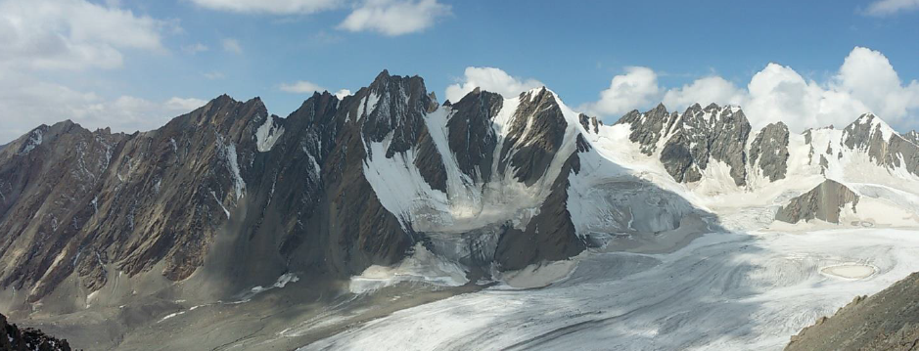
4. FACEBOOK AND WEB PAGES
4.1 National: abbreviated link for the national MCSA Facebook page: www.facebook.com/MCSA125/
4.2 Links for all the sections’ web pages are on the MCSA national webpage.

5. SECTION NEWS
5.1 KZN
Anyone who has ever been to a July Camp will be saddened by the following news out of KZN.
PASSING OF ISHMAEL NDLOVU - CHEF and INDUNA at JULY CAMP for OVER 50 YEARS!
All those who attended July Camps before 2005 are likely to have been delighted by the culinary expertise of our Chef and Induna, Ishmael Ndlovu. He attended some 57 July Camps, first in the role of Cook for the Camp Caterer until the early 60s and then took over as Chef and Induna.
His culinary skills were legendary, as were his warm sincerity, radiant smile and firm handshake as you came into Camp. It was the best Berg welcome one could wish for.
For many years he had been Chef at the Berg Hotels, but he fell under the spell of July Camp and wanted to attend Camp even though it was in July which is one of the peak seasons of the Berg hotels’ year. If the particular hotel he was working for at that time would not give him leave, he would resign, knowing that his reputation would get him a position at another Berg hotel. But Kay Nixon who was organising the Camps by that stage about his insecurity and lack of pension, so she secured him a position, with a pension, that assured him of leave for July Camp.
He was a passionate and inspired cook. After his retirement from ‘work’, he missed the opportunity to cook for a large group of people. July Camp offered him that opportunity. Cooking for appreciative, hungry Campers and trying out new variations of old favourites was his delight. Surely, he spent much time between Camps thinking up these variations. He would be beam radiantly when one noticed there was something a bit different this time. He was amenable to being asked to produce his excellent "crumpets and honey” for afternoon tea. Sad and annoyed were the Campers who got back too late, but usually the considerate Ishmael would produce some that he had stashed away. Another great treat that Ishmael introduced were the iced, steamed fruit cake Birthday Cakes!
He was a genial man and had a natural way of putting people at their ease. His ability to recognise Campers returning after a long absence was remarkable; he often remembered their names! He was a fluent English speaker and could pass the time of day in Afrikaans. But he enjoyed nothing more than when he could converse with a Camper in his own language, isi-Zulu. Among such people, farmers were his definite favourites.
He had a fine singing voice and one knew he was very happy when he sang as he worked. On the last night of July Camp, he would lead the other men as they came in to sing at the camp-fire. There would be a hymn, then at least one song about that particular camp and perhaps mentioning previous Camps. Then he would pause! A silent, but powerful, signal that all the Campers had to scramble up promptly and stand to attention to sing Sikhilele iAfrika, not as a party political song, but as hymn of our collective love of Africa.
When the then Organisers of the Camp realised that Ishmael was serious when he spoke of retiring, they decided to produce ‘Ishmael’s Cookbook’, a unique book of camp cooking, well illustrated with coloured pictures and sketches of Ishmael and his cooking.
In 2005, Ishmael passed on his Chef’s ladle to his son Vusi, who is the present July Camp Chef and Induna. Vusi, in turn, is training two of his sons, Jabulani and Xolani in these aspects of camp-craft. Ishmael’s influence is strongly entrenched in the July Camp of today and will be there for July Camps of the future. In fact, all the five men who now assist us at July Camp are members to the Ndlovu clan.
In recognition of his service to the July Camp and the Mountain Club, he was made an Honorary Life Member of the KwaZulu-Natal Section of the Mountain Club of South Africa and was deeply moved by this honour. He wore his membership badge with great pride.
It was a sad day for the July Camps of the future when Ishmael decided to retire after a remarkable 57 years of distinguished service. Campers and former Campers who knew Ishmael over that half century plus, revere his memory.
Rest in peace, dear friend.
Rikki Abbott Wedderburn
6. SNIPPETS

7. NEWSWORTHY ITEMS
Please send any newsworthy items for inclusion in MCSA National News Editor, Ineke Moseley at: inekemos@zsd.co.za
QUOTABLE QUOTES:
“It’s a round trip. Getting to the summit is optional, getting down is mandatory”
Ed Viesturs

