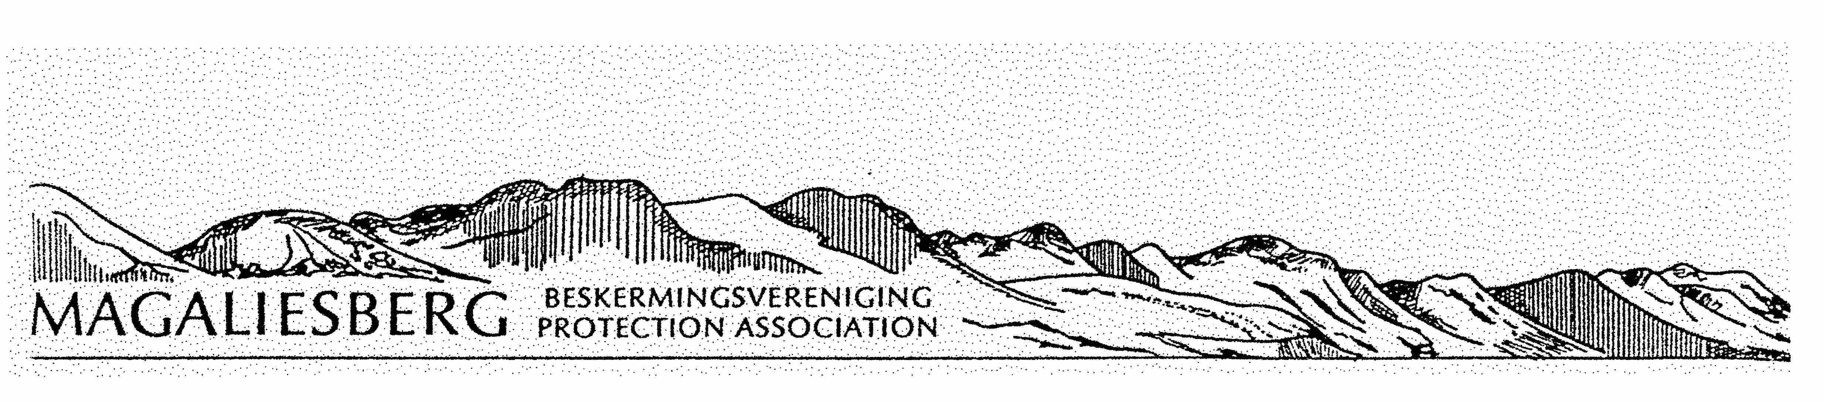 PO BOX 1641: HOUGHTON: 2041 NPO 043-713 email: info@magaliesberg.org.za Cell : 083 702 0530

THE 43RD ANNUAL GENERAL MEETING OF THE MEMBERS OF THE MAGALIESBERG PROTECTION ASSOCIATION WILL BE HELD AT “THE MARGARET ROBERTS HERBAL CENTRE” ON THE R513 IN DE WILDT ON SATURDAY 17 NOVEMBER 2018 AT 9.30AM

9h30-10h00 REGISTRATION

10h05 WELCOME BY THE CHAIRMAN

10h30 – 11h30 GUEST SPEAKER, ROD GENRICKS WILL SPEAK ON “FLOCULATION PRINCIPLES ARE THE DIRECT CAUSE OF THE COLLAPSE OF OUR WATER”

11h30-12h00 TEA

12h00 ANNUAL GENERAL MEETING

AGENDA

1 MINUTES OF THE 42nd ANNUAL GENERAL MEETING HELD 21 OCTOBER 2017

- CHAIRMAN’S REPORT

- FINANCIAL REPORT

- ELECTION OF EXECUTIVE COMMITTEE

- GENERAL

